**Prepare a project (local) for GitHub (remote)**

|  |
| --- |
| Git (master) |
| Project you want to upload (PUSH) to GitHub must:  **navigate to project in GitBush   1. Have .git folder   >>git init  will see (master)     1. Add/Commit all files in project   >>add .  >>commit –m “xxx”   1. git remote add origin   <https://github.com/Sanna2017/ff.git>  make connection to remote folder (origin)   1. git push (-u) origin ~~main~~ master   **do not include –u  Push your local project (master) to GitHub |

|  |
| --- |
| GitHub (origin) |
| Create repo on GitHub where project is going to be uploaded/pushed    Copy its URL/HTTPS |

**\*\*refresh GitHub**

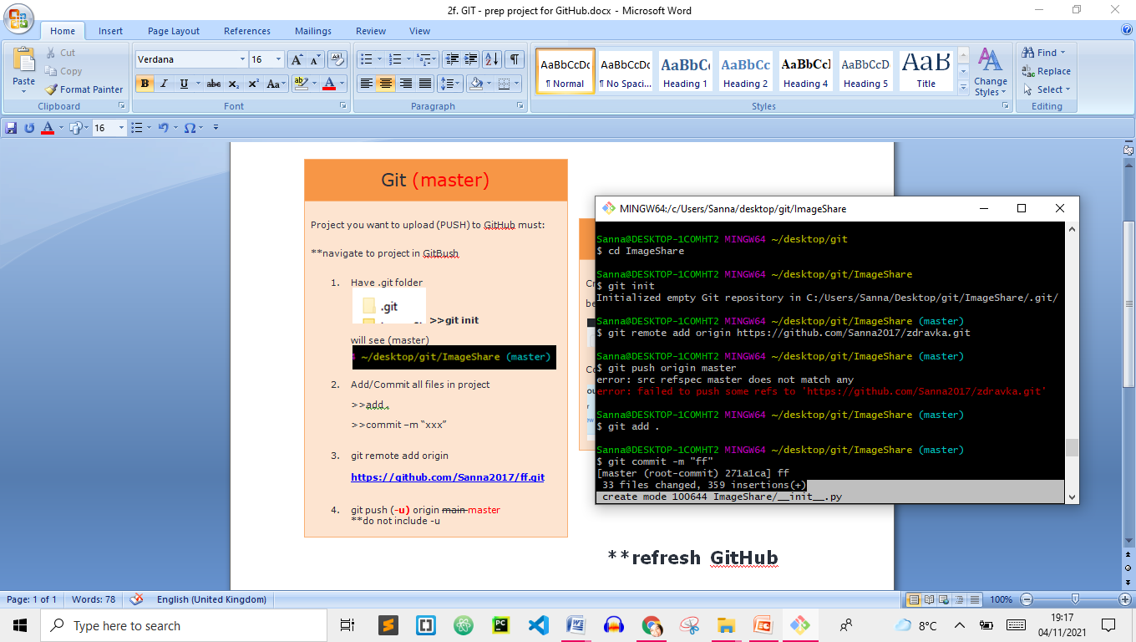

Push/send out MASTER to URL (we defined as ORIGIN)

ERROR MESSAGE if you do not GIT INIT

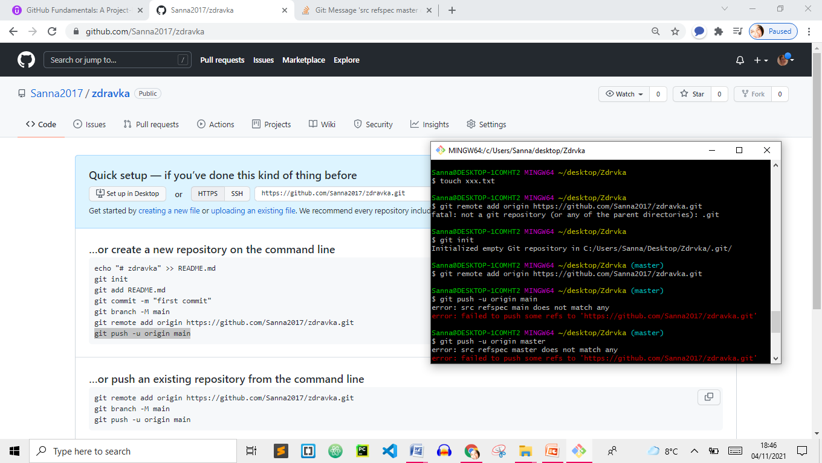

ERROR MESSAGE if you do not commit